SQL Programming Advanced – Week 4

Team: Cody Ferguson, Nathan Aird, Osman Abdirahman, and Landon Heezen

Item 1:

a.)

b.)

c.)

d.)

e.)

Item 2 (Landon Heezen):

a.)

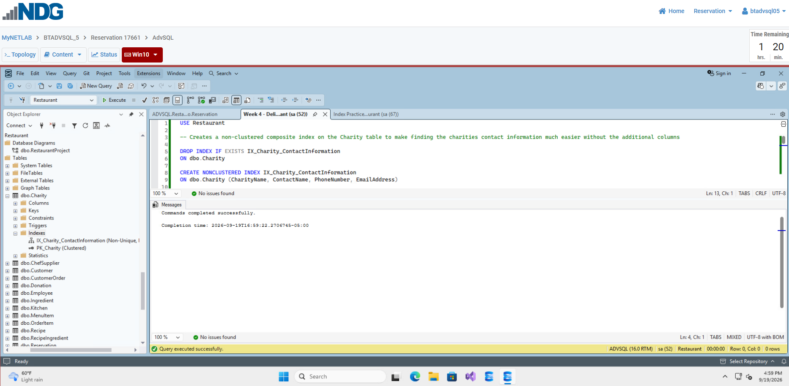
I made this index since the charities connected to the restaurant are of course their own organizations, so having a way to quickly access all contact information is incredibly useful should managers ever have to reach out to them, or if interested customers want to learn more about them beyond the collaborative events.

b.)

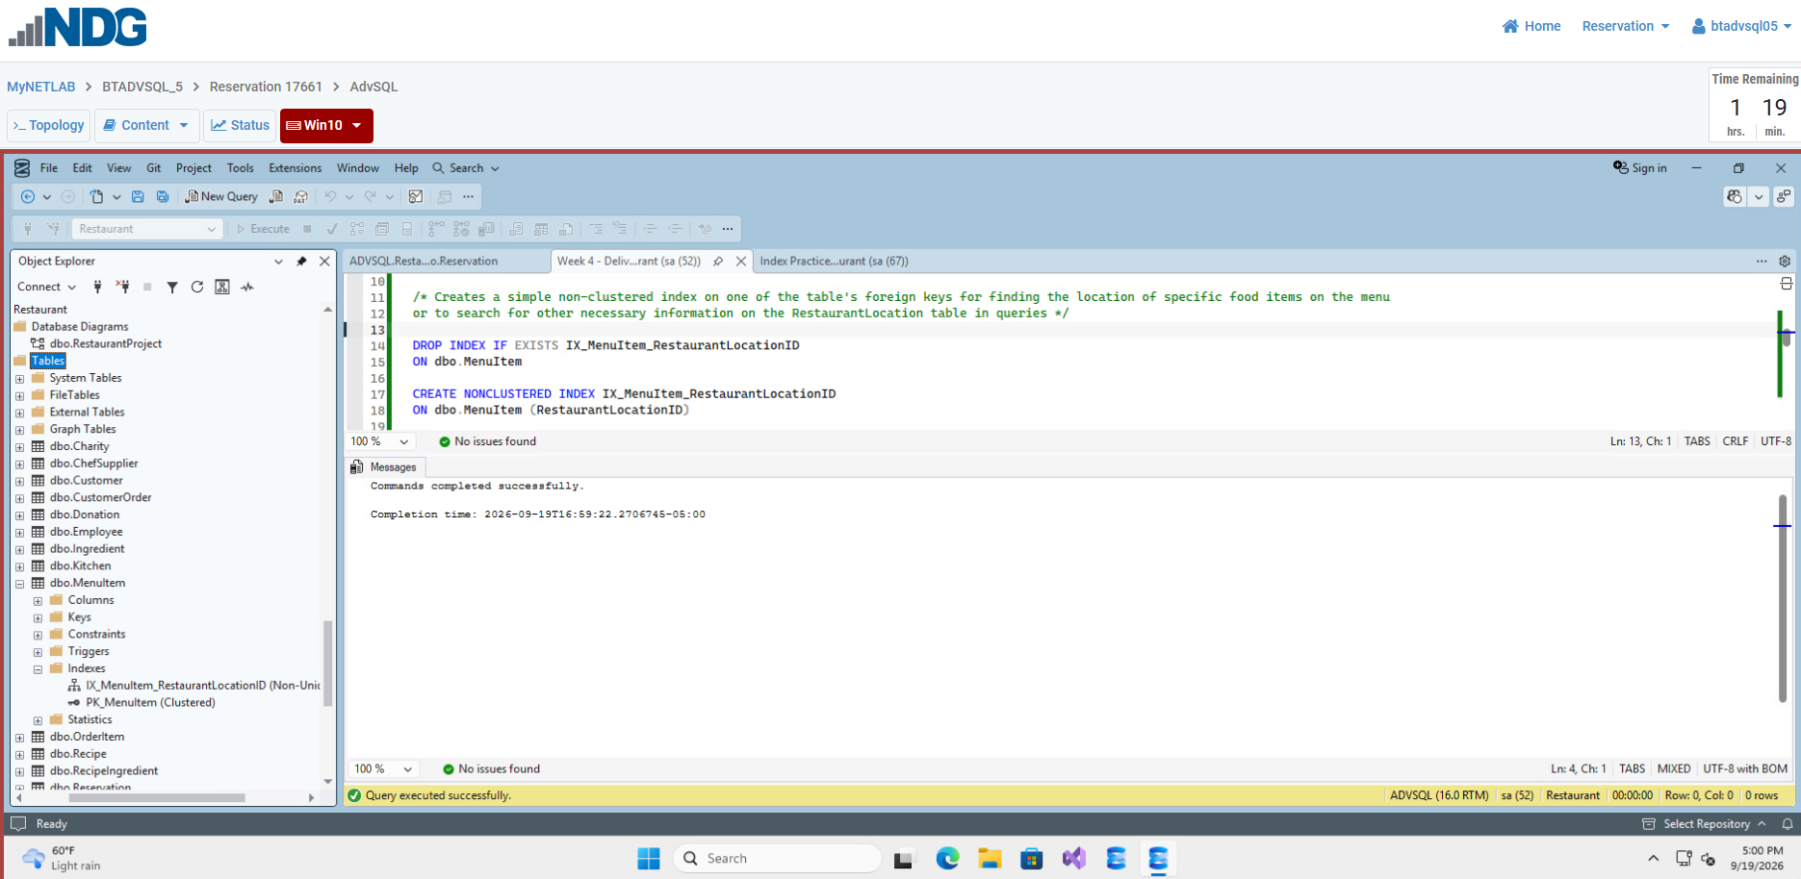
I made this index since popular restaurants often have multiple locations, and some might have special events or seasonal items with temporary food items available that aren’t available at other locations (also because the RestaurantLocationID is a foreign key), so having a way to quickly find the location’s information is important.

c.)

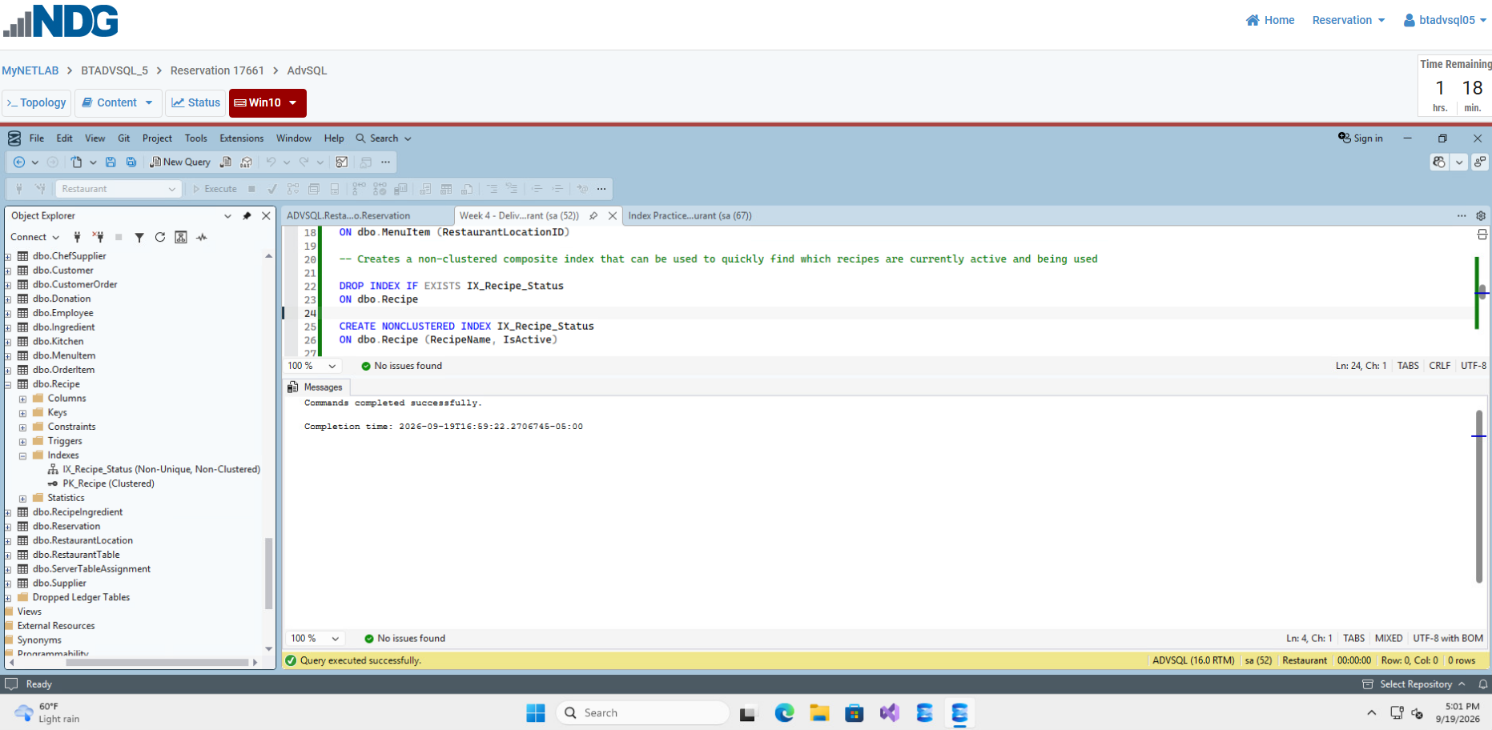
I made this index because often times depending on customer feedback, health concerns, or the price of ingredients, recipes will often have to change or be discontinued at a restaurant all together. This index provides a quick way to see what recipes are still active incase their status ever has be altered.

d.)

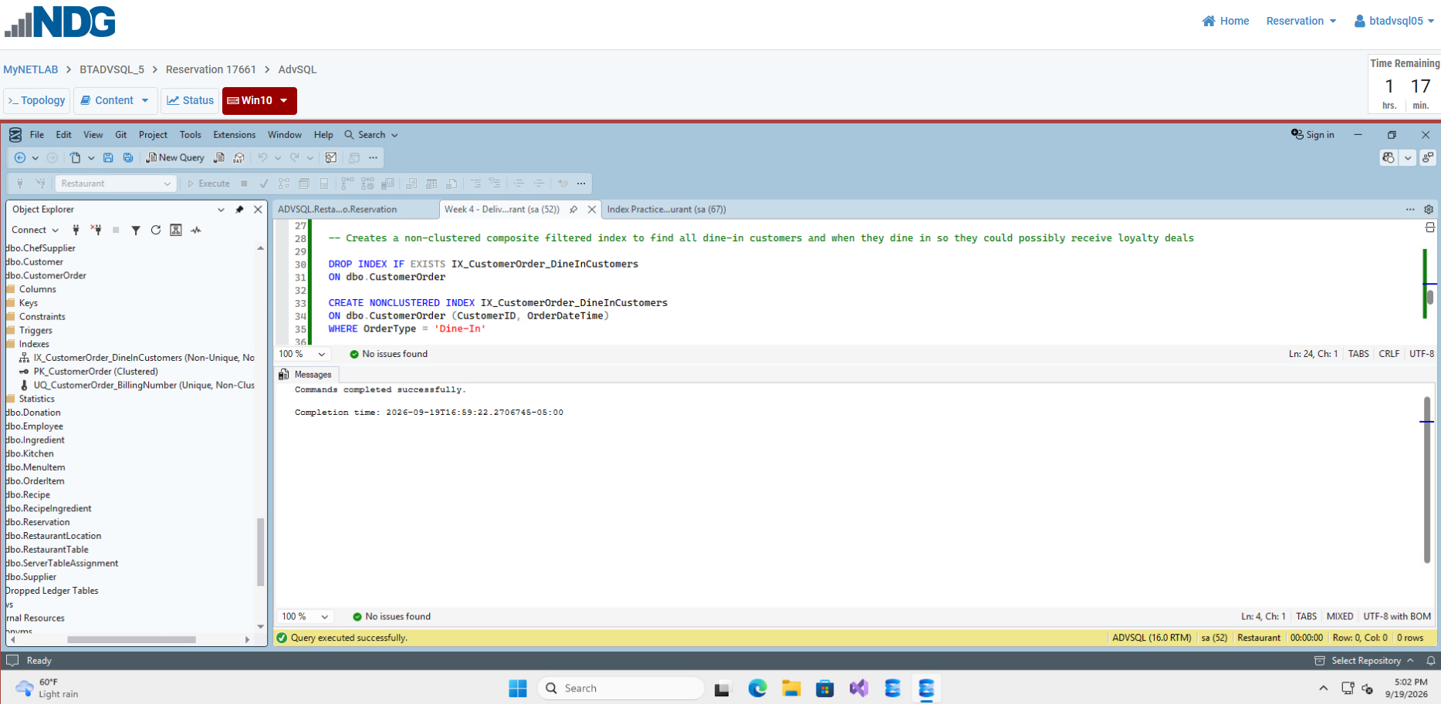
I made this index so all customers that dine-in can be documented and the date and times they visit can be recorded for setting up special deals when they arrive. Many restaurants use systems like this to keep customers coming back and/or to make their locations look packed and busy more often; giving onlookers the impression that the restaurant is popular and doing well financially. Depending on the restaurant, the order type they reward could differ, some restaurants encourage online ordering by offering tons of exclusive deals and coupons for doing so.

e.)

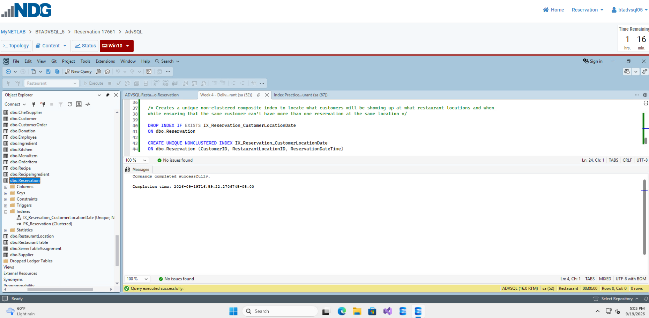
Lastly, I created this index to show which customers have reservations placed, what location their reservation is placed at, and the date and time they’re expected to arrive. It should go without saying that having quick access to this information is incredibly important so restaurant staff has time to prepare for these guests. It also makes it clear that a customer can’t have multiple reservations placed at the same location for obvious reasons.

Item 3:

Table 1 tests

Create
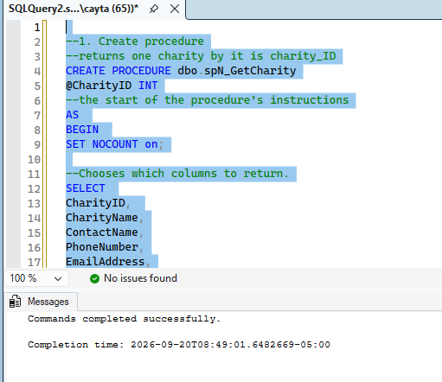
TEST
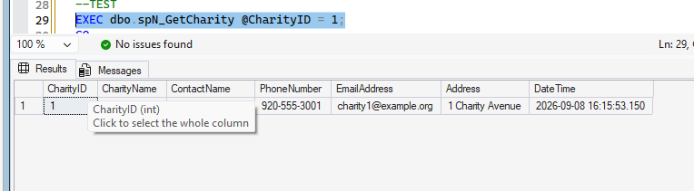
INSERT
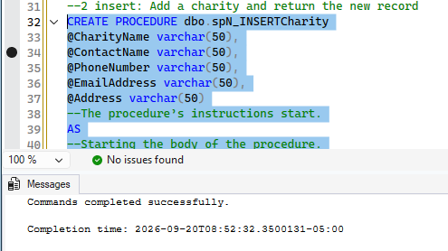
Test
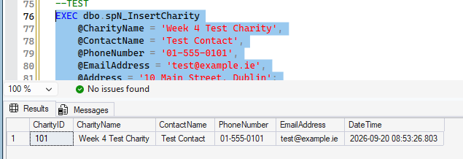
UPDATE
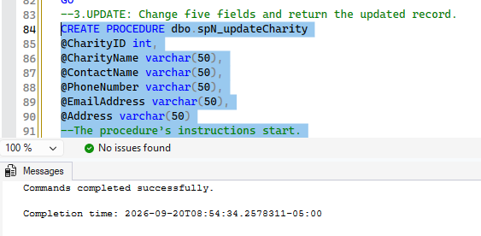
TEST
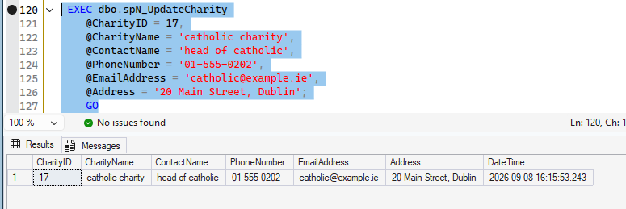
DELETE
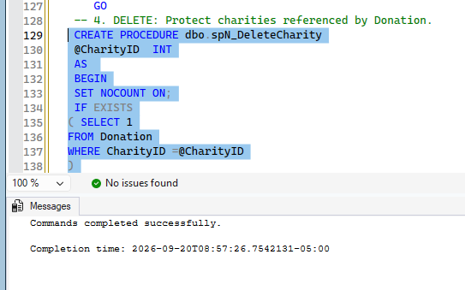
Test
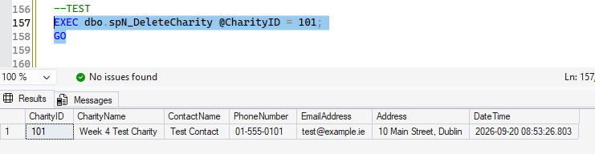
VERIFY
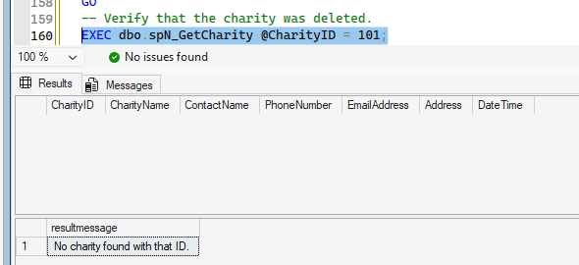
For the Charity table, the stored procedures are named spN_GetCharity, spN_InsertCharity, spN_UpdateCharity, and spN_DeleteCharity.
Table 2 tests

